Contents
1. General part 1
1.1. Husband 1
1.2. Wife 1
1.3. Children 1
2. Business Rules 2
3. Sketches 2

1. General part

Scope: Test application is purposed for collecting information about families, i.e. Husband, Wife and Children.

R 1001 Each family’s information (called ‘family database’) should be contained within 1 file, which can be saved with empty fields.
R1001.1 Several applications should be able to be launched simultaneously.

R 1002 When starting the Application the window should contain menu with three hinted standard buttons (New Database, Open Database, Save Database) and General tab should be enabled (see Sketch 1).
R 1002.1 These “New, Open, Save” buttons should be eligible also for other three tabs: Husband, Wife, Children. Button Save should be disabled until the user clicks on New (Open) button.

R 1003 To create a new family database the user should click on New button. The user might fill in Description (see BR 1002) of a family and select Date of marriage using Calendar (see BR 1001).

R 1004 To open an existing database the user should click on Open button, select from a dialog form and click on OK
R 1004.1 If the user is editing new (or opened) database and then clicks on New (or Open) button the application should propose to Save the current database (changes).

R1005 To save a current database the user should click on Save button.
R1005.1 The saved database name should be displayed in the top of application’s screen.
R1005.2 If opened database is not edited yet, the Save button should be disabled.
R1005.3 If the user saves database under the name which already exists in the path, the application should send the alert message if the user really wants to replace the existing file.

1.1. Husband

R 2001 To fill in the information about a husband the user should click on Husband tab (see Sketch 2)
R 2001.1 The following attributes of Husband might be filled in: First Name, Middle Name, Last Name (see BR 1003), Birth Day (BR 1001).
R 200.2 The field Age is blank by default. The field age shouldn’t be editable. It should be calculated by application as soon as Birth Day is filled in.

1.2. Wife
The Wife screen has the same interface and logic as Husband screen does.

1.3. Children
R 4001 To fill in the information about children the user should click on Children tab (see Sketch 3).

R 4002 The table (2 rows and 3 columns) with children should be empty in a new database. These 3 columns should have names “Name” and “Height” consequently.
R 4002.1 The cells in the table are not editable, but they can be selected.

R 4003 The user should be able to insert as many children as he wants. Scrolling should be displayed when table gets bigger sizes than screen has.

R 4004 The screen Children should have three hinted buttons Add Child, Del Child, Edit Child.
R 4004.1 If the table has no records Del Child and Edit Child buttons should be disabled.
R 4004.2 Add button should be always enabled

R 4005 When the user clicks on Add Child, the new screen should appear with 3 Attributes:
- Name (see BR 1003)
- Height (see BR 1004)
- Birth Day (see BR 1001)
R 4005.1 If the user clicks on OK the new record should appear in the table filled with filled attributes.
R 4005.2 If the user clicks on Cancel the table should be with no changes.

R 4006 To delete a child the user should select a record to delete and click on Del Child button. When the user click on this button the message should appear “Do you really want to delete the record?” If the user clicks on OK, the record should be deleted. If the user clicks on Cancel the record shouldn’t be deleted.

R 4007 If the user clicks on Edit Child button the screen with 3 attributes should appear. If the user clicks on OK, the changes should be applied to the table, if clicking on Cancel button then changes shouldn’t be applied.

2. Business Rules
BR 1001 The field of date (Date of marriage, Birth Day) should have the format MM\DD\YYYY. Other format should be ignored by the application. Date can be blank. The date can be typed manually or selected using the Calendar pop-up. The Calendar should have standard Windows UI.
.

BR 1002 Description field
- should be alphanumerical and may contain all special symbols
- should be of maximum length 50
- can be blank

BR 1003 The fields with Names (First Name, Last Name, Middle Name)
- should be alphanumerical and may contain all special symbols
- should be of maximum length 50
- can be blank

BR 1004 The field Height
- should be alphanumerical
- should be maximum 300 cm
- measuring should be in cm (label cm should exist in the form)
- should be entered manually or using Calculator pop-up. Calculator should have standard Windows UI
- can be blank

3. Sketches
Sketch 1
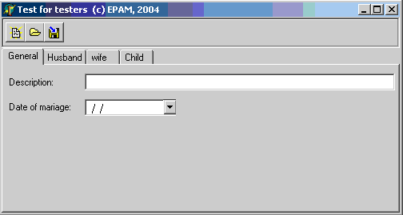

Sketch 2
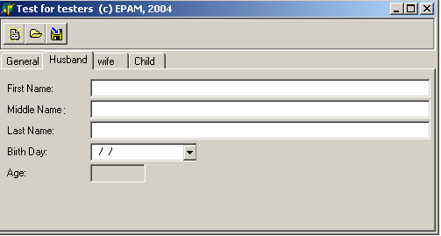

Sketch 3
